HELLO WORLD RESTFUL WEB SERVICE
Write a REST service in the spring learn application created earlier, that returns the text "Hello World!!" using Spring Web Framework. Refer details below:
Method: GET
URL: /hello
Controller: com.cognizant.spring-learn.controller.HelloController
Method Signature: public String sayHello()
Method Implementation: return hard coded string "Hello World!!"
Sample Request: http://localhost:8080/hello
Sample Response: Hello World!!

Controller.java
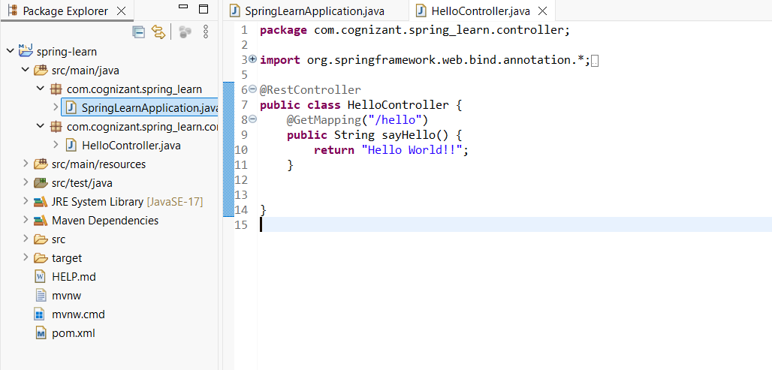

SpringlearnApplication.java

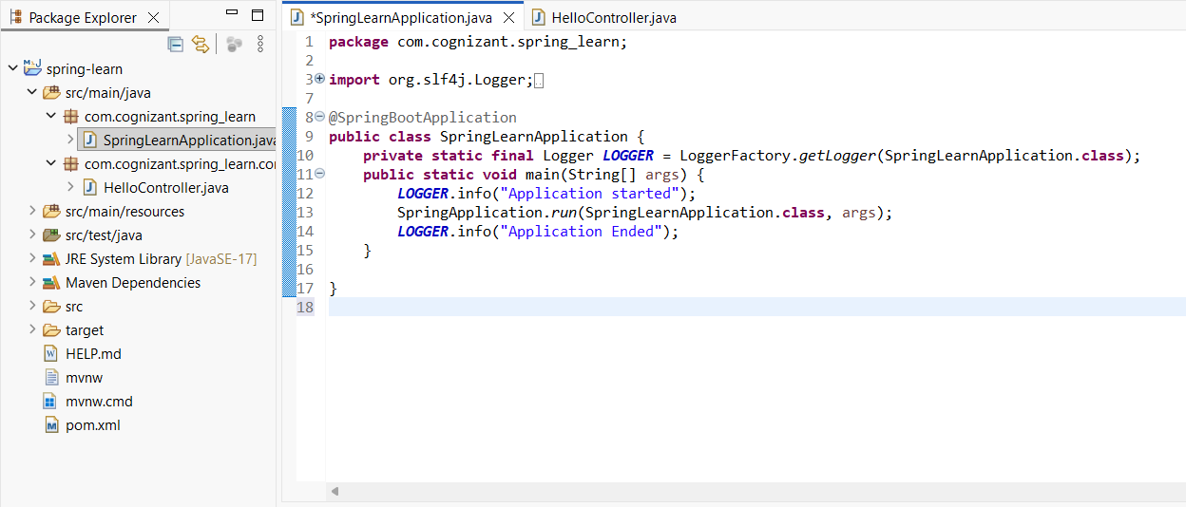

Output:
localhost
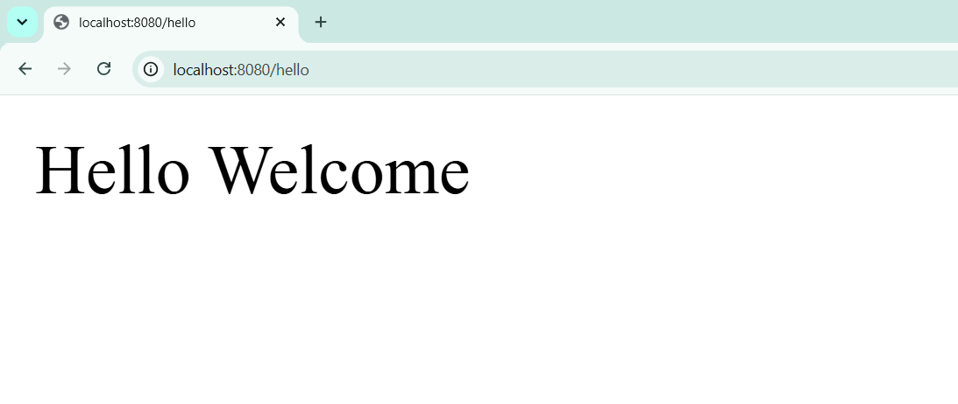
Logger output
